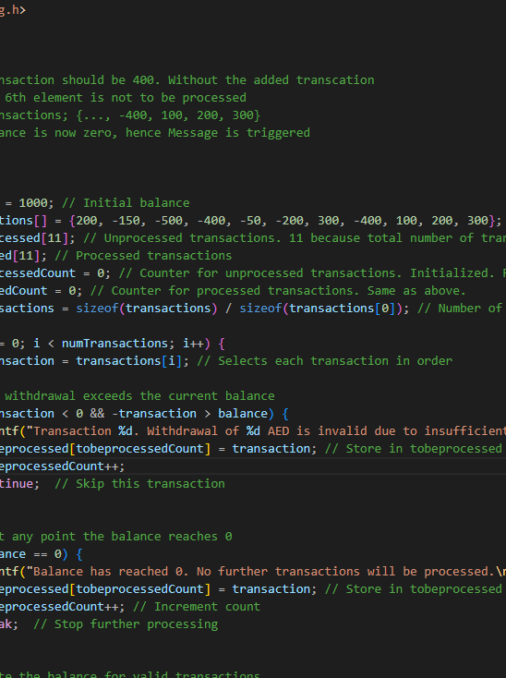

Lab 3: Arrays, C-struct, and C-string

Programming for Engineers Lab

Name: Ahmed Ismail | ID: 8541747 | Course Title: CSCI291 | Date: 27/10/2024

Table of Contents

1. Source Code Documentation 2

Question 1: Array Utility Functions 2

Question 2: Banking Transactions Processing 4

Question 3: League Team Application 5

2. Design Solutions 7

Question 1: Array Utility Functions 7

Question 2: Banking Transaction Processing Pseudocode 7

Question 2: Banking Transaction Processing Flow chart: 9

Question 3: search_update Function Design 9

Question 3: search_update Function FlowChart 11

3. Testing Evidence and Discussion 12

Question 1 Testing Results 12

Question 2 Testing Results 14

Question 3 Testing Results 14

GitHub Page: 18

# 1. Source Code Documentation

## Question 1: Array Utility Functions

**Part 1:**

* isValid: Validates array positions. If pos is valid, return true. Else return false.

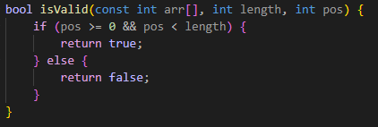

Figure 1 isValid Function code

* remove_element: Removes elements with upward shifting. Preserves first element as required. If pos is valid, it performs a **leftward shift** starting from the specified position. It uses a for loop to assign each element to the position to its right (arr[i] = arr[i-1]). This "removes" the element at pos by overwriting it.

Figure 2 remove_element Function code

* insert_element: Inserts elements with downward shifting. If valid, it performs a **rightward shift** to make room for the new value. It uses a for loop to shift each element to the left (arr[i] = arr[i+1]) up to the specified position. This shift causes the first element in the array to be overwritten by the second, and so on, until the new value is inserted at pos. After the loop, the function inserts value into arr[pos].

Figure 3 insert_element Function code

**Part 2:**

* reshape: Converts 1D array to 2D array column-wise. row and col keep track of the current position in the 2D array, with col incrementing until it reaches the number of columns (nCols). When col reaches nCols, it resets to 0, and row increments to move to the next row.

Figure 4 reshape Function code

* trans_matrix: Creates transpose of input matrix. The function iterates through each element in the input matrix (mat), switching the row and column indices when assigning values to the transposed matrix (mat_transp[j][i] = mat[i][j]).

Figure 5 trans_matrix Function code

* found_duplicate: Checks for duplicate values in array. It uses a nested loop to compare each element with all subsequent elements in the array. The outer loop iterates through each element, and the inner loop compares it with all elements that come after it. If a match is found (arr[i] == arr[j]), the function returns true, indicating a duplicate was found.

Figure 6 found_duplicate Function code

## Question 2: Banking Transactions Processing

**Code components:**

* Begins with initial balance of 1000 AED. Uses parallel arrays for tracking processed/unprocessed transactions. Implements transaction counters.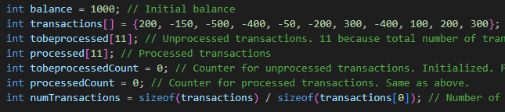

Figure 7 Initialization of balance, transaction and arrays code

* Implements validation for withdrawals, Handles zero balance condition. Uses separate arrays for tracking transaction status.

Figure 8 For loop of transaction processing

## Question 3: League Team Application

**Code components:**

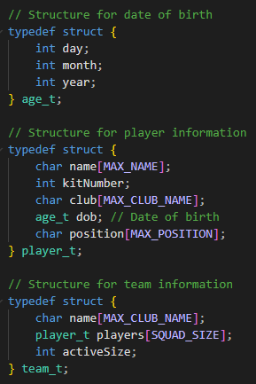

Figure 9 Structs declared for Question 3

Nested Structure Design:

* Uses typedef for clean syntax
* Implements hierarchical data organization
* Proper size constraints for strings

Memory Management:

* Fixed-size arrays for predictable memory usage
* No dynamic allocation required
* Efficient structure packing

**Core Functions:**

* enroll_club:

Figure 10 enroll_club code

* + Maintains team count
  + Validates against maximum teams
  + Uses pointer for count update
* add_player:
  + Club Selection
  + Play Information Noting
* search_update:
  + Search Options:
    - Name-based (case-insensitive)
    - Kit number-based
  + Update Options:
    - All player attributes modifiable
    - Maintains data integrity
  + Validation:
    - Duplicate checking
    - Range validation
    - Date validation
* Error Handling:

Figure 11 Error Handling message maker code

* Validation Functions:
  + Kit Number Validation
  + Date Validation
  + Duplicate Checking

# 2. Design Solutions

## Question 1: Array Utility Functions

Main functionalities:

1. isValid: Checks if a given position in an array is valid based on the array's length.
2. remove_element: Removes an element from an array by shifting all subsequent elements up.
3. insert_element: Inserts an element into an array by shifting all subsequent elements down.
4. reshape: Converts a 1D array into a 2D matrix with the specified number of rows and columns.
5. trans_matrix: Transposes a 2D matrix.
6. found_duplicate: Checks if an array contains any duplicate elements.

## Question 2: Banking Transaction Processing Pseudocode

Initialize:

Set balance = 1000

Create arrays: transactions[], tobeprocessed[], processed[]

Set counters: tobeprocessedCount = 0, processedCount = 0

Process Transactions:

FOR each transaction in transactions array:

IF transaction is withdrawal AND exceeds balance:

Print invalid transaction message

Add to tobeprocessed array

Continue to next transaction

IF balance is 0:

Print zero balance message

Add remaining transactions to tobeprocessed

Break loop

Update balance with transaction

Add to processed array

Increment processed counter

Output Results:

Print final balance

Print all processed transactions

Print all unprocessed transactions

## Question 2: Banking Transaction Processing Flow chart:

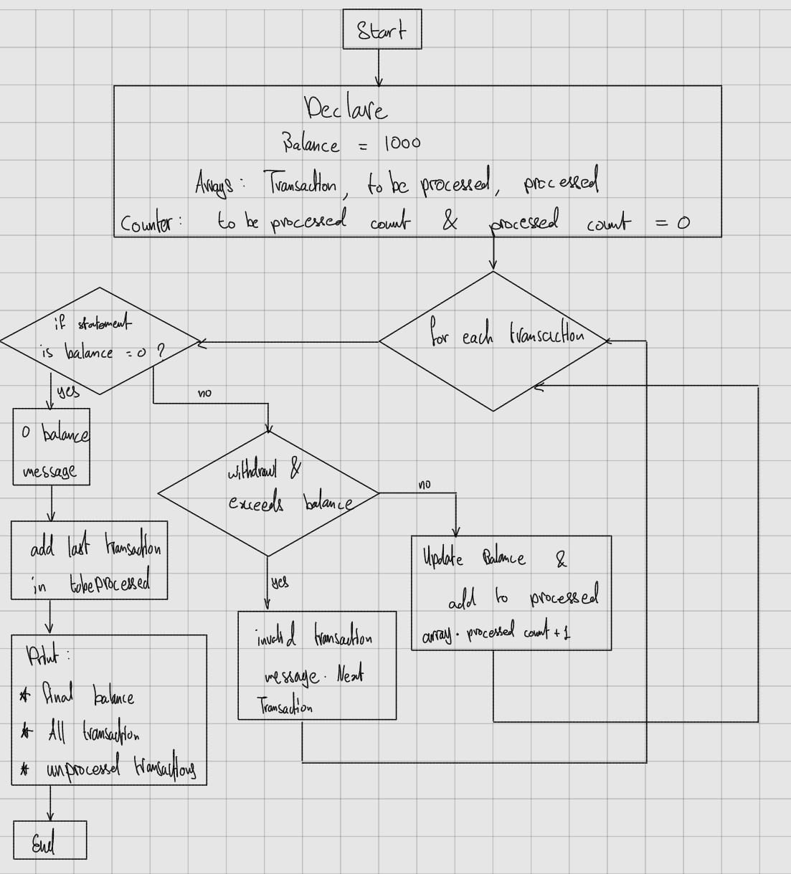

Figure 12 Question 2 Code Flow Chart

## Question 3: search_update Function Design

Structure Access Explanation:

1. The function accesses struct data through nested structures:

team_t teams[] -> player_t players[] -> Individual fields

Data access patterns:

* Direct access: teams[i].name
* Nested access: teams[i].players[j].name
* Pointer access: player_t *player = &teams[foundTeamIndex].players[foundPlayerIndex]

The search_update function follows this workflow:

1. Takes user input for search method (name/kit number)
2. Traverses team and player arrays using nested loops
3. Uses pointer to found player for efficient updates
4. Implements validation before updates
5. Maintains data integrity through duplicate checks

## Question 3: search_update Function FlowChart

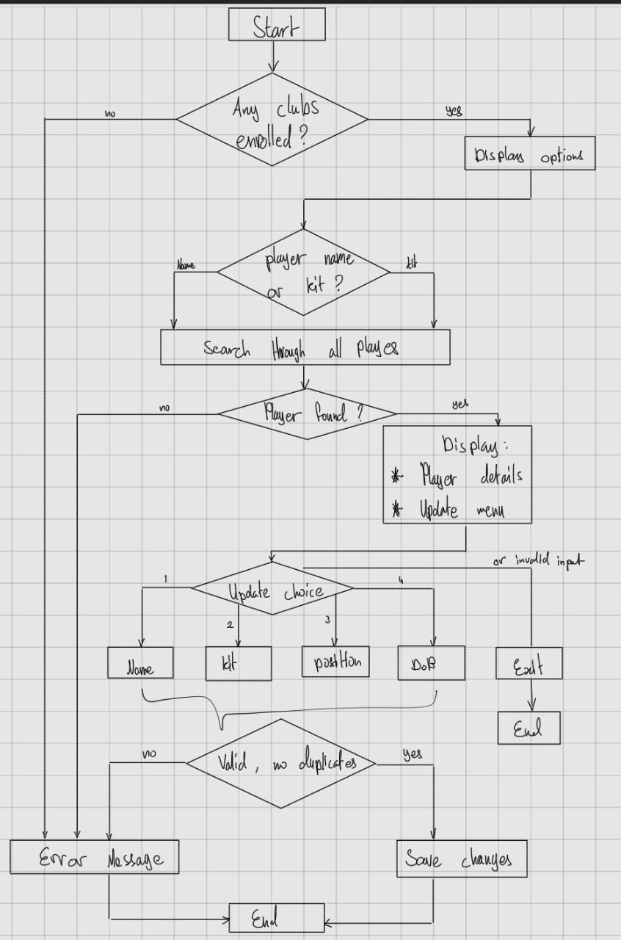

Figure 13 Question 3 Code Flow Chart

# 3. Testing Evidence and Discussion

## Question 1 Testing Results

Test case 1: isValid function testing

Figure 14 isValid Test Evidence

Test Case 2: remove_element demonstration

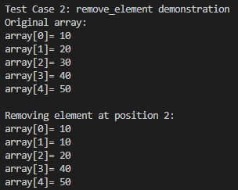

Figure 15 remove_element Test Evidence

Test Case 3: remove_element with invalid position

Figure 16 remove_element invalid Test Evidence

Test Case 4: insert_element demonstration

Figure 17 insert_element Test Evidence

Test Case 5: insert_element with invalid position

Figure 18 insert_element invalid Test Evidence

Test case 6: Reshaped 2D array

Figure 19 reshape Test Evidence

Test case 7: Transposed matrix

Figure 20 trans_matrix Test Evidence

Test case 8: found_duplicate



Figure 21 found_duplicate Test Evidence

## Question 2 Testing Results

Figure 22 Question 2 Test Evidence

## Question 3 Testing Results

Club enrolment:

Figure 23 Enrolment Test Evidence

Player addition:

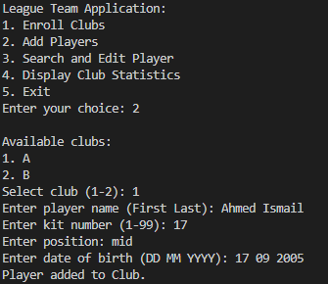

Figure 24 Player addition Test Evidence

Figure 25 Player addition proof in Club Statistics

Search and update functionality verified:

Figure 26 Update Functionality for several cases Test Evidences

Figure 27 More Update Functionality Test Evidences

Statistics display correctly formatted:

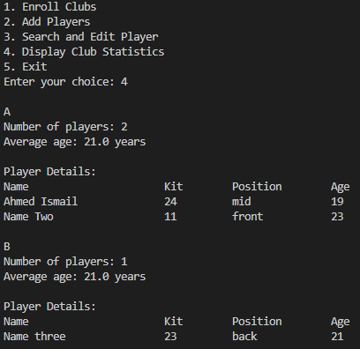

Figure 28 Statistics Display Test Evidence

Invalid Entries Tests:

Figure 29 Invalid Entries, Duplicates and such Test Evidence

# GitHub Page:

*https://github.com/AIsmail17/CSCI291-Lab-3-Evidence.git*